
https://doi.org/10.70401/tx.2025.0002

Supplementary information

Kinetic simulation of magnetic-field-tuned hydro-dynamic electron transport in a graphene Corbino disk

Chuang Zhang, Meng Lian, Hong Liang, Xiaokang Li, Zhaoli Guo, Jing-Tao Lü

Numerical validations and grid independence
Modular program verification is a commonly used method in large-scale computing. This appendix will gradually verify the numerical performance of the present algorithm.

Firstly, the cross-plane electronic heat conduction in a thin Au metal film is simulated with thickness L. The temperatures at both ends of the film are fixed with T_{L} = T₀ + ΔT, T_{R} = T₀ - ΔT, respectively, where ΔT << T₀. Isothermal boundary condition is applied for both ends of the film. The electronic band structure of the Au material is treated using the free electron approximation model. Specific electronic property parameters and energy band structures of the Au materials can be found in our previous paper^{[6]} as well as the numerical discretizations. The initial chemical potential of the entire computational domain is all at the Fermi level E_{F} = 5.51 eV. Numerical results predicted by the present scheme are compared with the Monte Carlo solutions^{[68]} at different film thickness, as shown in Figure 7. The profiles showed that the present scheme can accurately capture different-sized electronic heat conduction phenomena under the temperature gradients.

Secondly, the in-plane electron transport in Au materials is simulated under temperature gradient or electric field force. Diffusely reflecting adiabatic or insulating boundary conditions are adopted for both the upper and lower boundaries, and periodic boundary conditions are used for left and right boundaries. The distance between the upper and lower boundaries is H. When a constant and very small temperature gradient is applied in the left-right direction, the system temperature increase is not significant, and the chemical potential inside is approximately the Fermi energy level. A parabolic-like heat flux distribution will be generated in the vertical direction of the temperature gradient and an analytical solution can be obtained for this electronic thermal transport process. Similarly, when a constant and very small electric filed force is applied in the left-right direction, the system temperature increase is not significant. A parabolic-like electronic current distribution will be generated in the vertical direction of the electric field force and an analytical solution can be obtained for this electron transport process^{[6,69,70]}. It can be found that the numerical results predicted by the present scheme are in excellent agreement with the analytical solutions at different H in Figure 8.

Thirdly, grid independence validation is conducted for graphene Corbino disk under the electric field, as shown in Figure 2(a), where N_{α}, N_{B} and M are the number of discrete solid angle, energy bands and spatial cells in each direction. When mathstart ${\text{τ}}_{\text{mr}}^{\text{∗}}\text{ = 0.01}$ mathend or mathstart ${\text{τ}}_{\text{mc}}^{\text{∗}}\text{ = 0.01}$ mathend, ‘Less mesh’: N_{α} = 20, N_{B} = 20, M = 200, N_{k} = 10, ‘More mesh’: N_{α} = 40, N_{B} = 40, M = 300, N_{k} = 15. When mathstart ${\text{τ}}_{\text{mr}}^{\text{∗}}\text{=0.1}$ mathend or mathstart ${\text{τ}}_{\text{mc}}^{\text{∗}}\text{=0.1}$ mathend, ‘Less mesh’: N_{α} = 40, N_{B} = 40, M = 200, N_{k} = 10, ‘More mesh’: N_{α} = 80, N_{B} = 96, M = 300, N_{k} = 15. It can be found that the present numerical discretizations of the phase space are acceptable to ensure the numerical simulation accuracy.

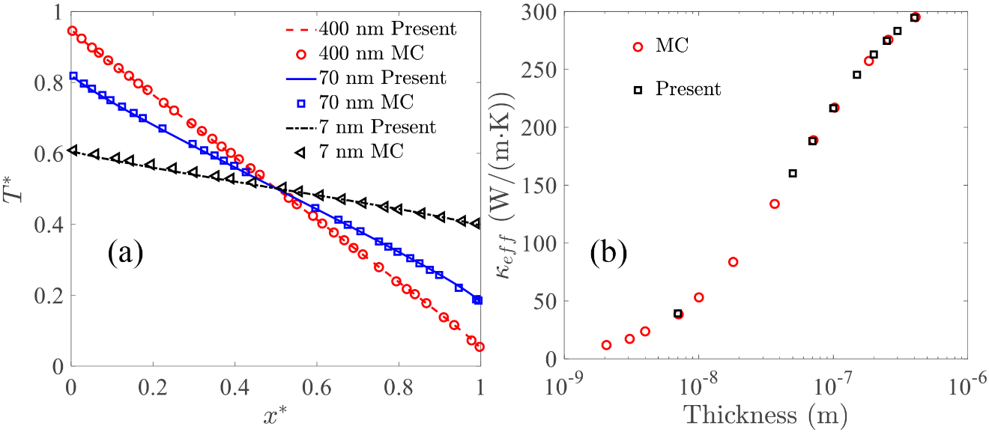
Figure 7. (a) Steady-state temperature spatial distributions, where x* = x/L and T* = (T -T_{R})/(T_{L} - T_{R}) are the normalized coordinate and temperature, respectively; (b) Size effects of cross-plane electron thermal transport in Au films, where κ_{eff} = q L/(T_{L} - T_{R}). ‘MC’ is the data obtained from reference^{[68]} and ‘Present’ is the present results.

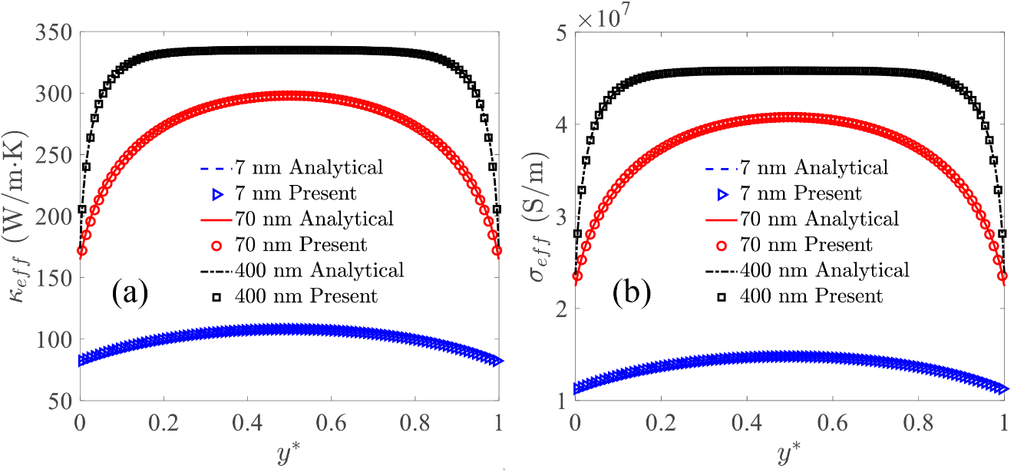
Figure 8. (a) Spatial distributions of the effective thermal conductivity under the temperature gradient; (b) Spatial distributions of the effective electric conductivity under the electric filed force. ‘Analytical’ is the analytical solutions obtained from previous papers^{[6,69,70]} and ‘Present’ is the present results κ_{eff} = q/(dT/dx), σ_{eff} = j/(E), y* = y/H is the normalized coordinate.

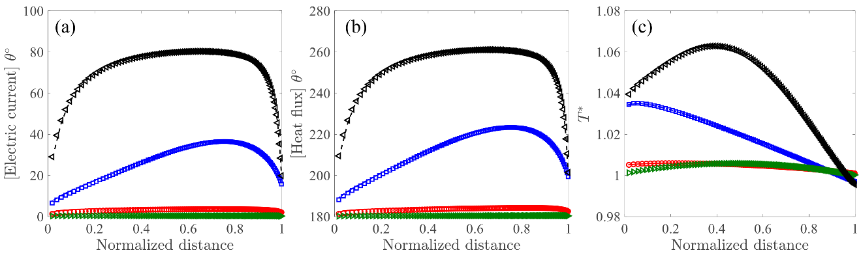
Figure 9. All introduction are the same as Figure 2, where lines ares the ‘Less mesh’, and symbols are ‘More mesh’.

References
6.Lian M, Zhang C, Guo Z, Lü JT. Discrete unified gas kinetic scheme for the solution of electron boltzmann transport equation with callaway approximation. Phys Rev E. 2024;109(6-2):065310. [DOI:10.1103/PhysRevE.109.065310 PMID:39020968]
68.Miao W, Guo Y, Ran X, Wang M. Deviational Monte Carlo scheme for thermal and electrical transport in metal nanostructures. Phys Rev B. 2019;99(20):205433. [DOI:10.1103/physrevb.99.205433]
69.Fuchs K. The conductivity of thin metallic films according to the electron theory of metals. Math Proc Camb Phil Soc. 1938;34(1):100-108. [DOI:10.1017/s0305004100019952]
70.Sondheimer EH. The mean free path of electrons in metals. Adv Phys. 1952;1(1):1-42. [DOI:10.1080/00018735200101151]

