
https://doi.org/10.70401/tx.2026.0027

Supplementary information

A cumulative model for thermoelectric cooling with temperature dependent material properties

Kang Zhu, Xuechun Li, Alex Brown, Rujie Shi, Hee Seok Kim, Weishu Liu

1.Derivation of the original cumulative model
This section presents the detailed derivation of the maximum COP and nondimensional cooling power density given by Eq. (3) in the original cumulative model. It starts from the one-dimensional governing equation of the thermal and electrical flow within a thermoelectric element in steady state,
$$\begin{aligned}\frac{d}{dx}\left(κ\left(T\right)\frac{dT}{dx}\right)+J^{2}ρ\left(T\right)−Jτ\left(T\right)\frac{dT}{dx}=0\#\left(S1\right)\end{aligned}$$
where J is the current density from the cold to hot side of the element, and x is the coordinate in parallel to J. By integrating Eq. (S1) twice with respect to x, the following equations are obtained,
$$\begin{aligned}κ\left(T\right)\frac{dT}{dx}+J^{2}\int_{0}^{x}{ρ\left(T\right)dx}−J\int_{T_{c}}^{T}{τ\left(T\right)dT}+C_{1}=0\#\left(S2\right)\end{aligned}$$
$$\begin{aligned}\int_{T_{c}}^{T}{κ\left(T\right)dT}+J^{2}\int_{0}^{x}{\int_{0}^{x}{ρ\left(T\right)dx}dx}−J\int_{0}^{x}{\int_{T_{c}}^{T}{τ\left(T\right)dT}dx}+C_{1}x+C_{2}=0\#\left(S3\right)\end{aligned}$$
Applying the boundary conditions, $T=T_{c}$ at $x=0$ and $T=T_{h}$ at $x=L$, to the above integral equations, where L is the length of the element, $C_{1}$ and $C_{2}$ are deduced as
$$\begin{aligned}C_{2}=0\#\left(S4\right)\end{aligned}$$
and
$$\begin{aligned}C_{1}=−{\left.κ\left(T_{c}\right)\frac{dT}{dx}\right|}_{x=0}=−\frac{1}{L}\left[\int_{T_{c}}^{T_{h}}{κ\left(T\right)dT}+J^{2}\int_{0}^{L}{\int_{0}^{x}{ρ\left(T\right)dx}dx}−J\int_{0}^{L}{\int_{T_{c}}^{T}{τ\left(T\right)dT}dx}\right]\#\left(S5\right)\end{aligned}$$
Thus, the cooling power density, i.e., the heat flux at the cold side is given by
$$\begin{aligned}q_{c}=−\frac{1}{L}\int_{T_{c}}^{T_{h}}{κ\left(T\right)dT}+J\left[S\left(T_{c}\right)T_{c}+\frac{1}{L}\int_{0}^{L}{\int_{T_{c}}^{T}{τ\left(T\right)dT}dx}\right]−J^{2}\frac{1}{L}\int_{0}^{L}{\int_{0}^{x}{ρ\left(T\right)dx}dx}\#\left(S6\right)\end{aligned}$$
The electric power input is given by
$$\begin{aligned}P=I\int_{T_{c}}^{T_{h}}{S\left(T\right)dT}+I^{2}R\#\left(S7\right)\end{aligned}$$
where $I=JA$ is the electric current and $R=\frac{1}{A}\int_{0}^{L}{ρ\left(T\right)dx}$ is the electric resistance of the element. Divided by the cross-sectional area A, the input power density is
$$\begin{aligned}P_{dens}=J\int_{T_{c}}^{T_{h}}{S\left(T\right)dT}+J^{2}\int_{0}^{L}{ρ\left(T\right)dx}\#\left(S8\right)\end{aligned}$$
Prior to further derivation, the integral terms with respect to x are converted into those with respect to T assuming a linear relation between T and x,
$$\begin{aligned}\int_{0}^{L}{ρ\left(T\right)dx}=\int_{0}^{L}{ρ\left(T\right)\frac{dx}{dT}dT}≈\frac{L}{∆T}\int_{T_{c}}^{T_{h}}{ρ\left(T\right)dT}\#\left(S9\right)\end{aligned}$$
$$\begin{aligned}\int_{0}^{L}{\int_{0}^{x}{ρ\left(T\right)dx}dx}≈\frac{L^{2}}{{∆T}^{2}}\int_{T_{c}}^{T_{h}}{\int_{T_{c}}^{T}{ρ\left(T\right)dT}dT}\#\left(S10\right)\end{aligned}$$
$$\begin{aligned}\int_{0}^{L}{\int_{T_{c}}^{T}{τ\left(T\right)dT}dx}≈\frac{L}{∆T}\int_{T_{c}}^{T_{h}}{\int_{T_{c}}^{T}{τ\left(T\right)dT}dT}\#\left(S11\right)\end{aligned}$$
Introducing the nondimensional factors $W_{J}$ and $W_{T}$ given by Eq. (5), the cooling power density and electric power density are rewritten as
$$\begin{aligned}q_{c}=−\frac{1}{L}\int_{T_{c}}^{T_{h}}{κ\left(T\right)dT}+J\left[S\left(T_{c}\right)T_{c}+W_{T}\int_{T_{c}}^{T_{h}}{τ\left(T\right)dT}\right]−J^{2}W_{J}\frac{L}{∆T}\int_{T_{c}}^{T_{h}}{ρ\left(T\right)dT}\#\left(S12\right)\end{aligned}$$
$$\begin{aligned}P_{dens}=J\int_{T_{c}}^{T_{h}}{S\left(T\right)dT}+J^{2}\frac{L}{∆T}\int_{T_{c}}^{T_{h}}{ρ\left(T\right)dT}\#\left(S13\right)\end{aligned}$$
According to Eq. (S12), the maximum cooling power density is reached as
$$\begin{aligned}q_{c,max}=−\frac{1}{L}\int_{T_{c}}^{T_{h}}{κ\left(T\right)dT}+\frac{{\left[S\left(T_{c}\right)T_{c}+W_{T}\int_{T_{c}}^{T_{h}}{τ\left(T\right)dT}\right]}^{2}}{4W_{J}\frac{L}{∆T}\int_{T_{c}}^{T_{h}}{ρ\left(T\right)dT}}\#\left(S14\right)\end{aligned}$$
when
$$\begin{aligned}J=\frac{\left[S\left(T_{c}\right)T_{c}+W_{T}\int_{T_{c}}^{T_{h}}{τ\left(T\right)dT}\right]}{2W_{J}\frac{L}{∆T}\int_{T_{c}}^{T_{h}}{ρ\left(T\right)dT}}\#\left(S15\right)\end{aligned}$$
Substituting $α_{0}=\frac{T_{c}S\left(T_{c}\right)+W_{T}\int_{T_{c}}^{T_{h}}{τ\left(T\right)dT}}{\int_{T_{c}}^{T_{h}}{S\left(T\right)dT}}$ into Eqs. (S14-15) and identifying $\frac{1}{L}\int_{T_{c}}^{T_{h}}{κ\left(T\right)dT}$ to be the thermal conducting heat flux under $∆T$, the expressions for the maximum nondimensional cooling power density and the corresponding electric current density are obtained,
$$\begin{aligned}\frac{q_{c, max}}{q_{cond}}=\frac{α_{0}^{2}}{4W_{J}}\frac{{\left(\int_{T_{c}}^{T_{h}}{S\left(T\right)dT}\right)}^{2}}{\int_{T_{c}}^{T_{h}}{ρ\left(T\right)dT}\int_{T_{c}}^{T_{h}}{κ\left(T\right)dT}}ΔT−1=\frac{α_{0}^{2}}{4W_{J}}(ZT)_{eng}−1\#\left(S16\right)\end{aligned}$$
$$\begin{aligned}J=\frac{α_{0}\int_{T_{c}}^{T_{h}}{S\left(T\right)dT}}{2W_{J}\frac{L}{∆T}\int_{T_{c}}^{T_{h}}{ρ\left(T\right)dT}}\#\left(S17\right)\end{aligned}$$
The COP is obtained by dividing the cooling power density by electric power density,
$$\begin{aligned}COP=\frac{−\frac{1}{L}\int_{T_{c}}^{T_{h}}{κ\left(T\right)dT}+J\left[S\left(T_{c}\right)T_{c}+W_{T}\int_{T_{c}}^{T_{h}}{τ\left(T\right)dT}\right]−J^{2}W_{J}\frac{L}{∆T}\int_{T_{c}}^{T_{h}}{ρ\left(T\right)dT}}{J\int_{T_{c}}^{T_{h}}{S\left(T\right)dT}+J^{2}\frac{L}{∆T}\int_{T_{c}}^{T_{h}}{ρ\left(T\right)dT}}\#\left(S18\right)\end{aligned}$$
Letting $\frac{dCOP}{dJ}=0$, the maximum COP and the corresponding electric current density are deduced after some algebra,
$$\begin{aligned}{COP}_{max}=\frac{α_{0}\sqrt{1+α_{1}(ZT)_{eng}}−α_{2}}{\sqrt{1+α_{1}(ZT)_{eng}}+1}\#\left(S19\right)\end{aligned}$$
$$\begin{aligned}J=\frac{∆T}{L}\frac{\int_{T_{c}}^{T_{h}}{S\left(T\right)dT}}{\int_{T_{c}}^{T_{h}}{ρ\left(T\right)dT}}\frac{1}{\sqrt{1+α_{1}(ZT)_{eng}}−1}\#\left(S20\right)\end{aligned}$$
The $α_{i}$ terms (i = 0, 1, 2) are given by Eq. (4).

2.Refinement of the cumulative model
This section presents a refinement of the cumulative model based on a direct comparison between $\int_{0}^{L^{'}}{ρdx}$ and $\frac{L^{'}}{ΔT^{'}}\int_{T_{c}}^{T_{h}^{'}}{ρdT}$. Assuming a linear relationship between the electric resistivity and temperature (which is not true for many TE materials over a relatively large temperature range, but it is sufficient in this context for a qualitative explanation),
$$\begin{aligned}ρ=ρ_{0}+γ\left(T−T_{c}\right)\#\left(S21\right)\end{aligned}$$
the integration of $ρ$ over $x$ is unfolded as
$$\begin{aligned}\int_{0}^{L^{'}}{ρdx}=\int_{0}^{L^{'}}{\left[ρ_{0}+γ\left(T−T_{c}\right)\right]dx}\#\left(S22\right)\end{aligned}$$
The temperature evolution along the TE element is approximated by
$$\begin{aligned}T=−\frac{\overline{ρ}J^{2}}{2\overline{κ}}x^{2}+\left(\frac{\overline{ρ}J^{2}}{2\overline{κ}}L+\frac{ΔT}{L}\right)x+T_{c}\#\left(S23\right)\end{aligned}$$
under the constant-property assumption. So Eq. (S22) can be further unfolded as
$$\begin{aligned}\int_{0}^{L^{'}}{ρdx}=ρ_{0}L^{'}+γ{L^{'}}^{2}\left[−\frac{\overline{ρ}J^{2}}{6\overline{κ}}L^{'}+\frac{1}{2}\left(\frac{\overline{ρ}J^{2}}{2\overline{κ}}L+\frac{ΔT}{L}\right)\right]\#\left(S24\right)\end{aligned}$$
And $\frac{L^{'}}{ΔT^{'}}\int_{T_{c}}^{T_{h}^{'}}{ρdT}$ is unfolded as
$$\begin{aligned}\frac{L^{'}}{ΔT^{'}}\int_{T_{c}}^{T_{h}^{'}}{ρdT}=ρ_{0}L^{'}+γ{L^{'}}^{2}\left[−\frac{\overline{ρ}J^{2}}{4\overline{κ}}L^{'}+\frac{1}{2}\left(\frac{\overline{ρ}J^{2}}{2\overline{κ}}L+\frac{ΔT}{L}\right)\right]\#\left(S25\right)\end{aligned}$$
According to Eqs. (S24) and (S25),
$$\begin{aligned}\int_{0}^{L^{'}}{ρdx}=\frac{L^{'}}{ΔT^{'}}\int_{T_{c}}^{T_{h}^{'}}{ρdT}+\frac{1}{12}γ{L^{'}}^{3}\frac{\overline{ρ}J^{2}}{\overline{κ}}\#\left(S26\right)\end{aligned}$$
From Eq. (S23) the location coordinate corresponding to the peak temperature is given by
$$\begin{aligned}L^{'}=\frac{1}{2}L+\frac{\overline{κ}}{\overline{ρ}J^{2}}\frac{ΔT}{L}\#\left(S27\right)\end{aligned}$$
Substituting it into Eq. (S26),
$$\begin{aligned}\int_{0}^{L^{'}}{ρdx}=\frac{L^{'}}{ΔT^{'}}\int_{T_{c}}^{T_{h}^{'}}{ρdT}+\frac{1}{96}γL^{3}\frac{\overline{ρ}J^{2}}{\overline{κ}}+\frac{1}{12}γ{\left(\frac{\overline{κ}}{\overline{ρ}J^{2}}\right)}^{2}{\left(\frac{ΔT}{L}\right)}^{3}+\frac{1}{16}γLΔT+\frac{1}{8}γ\frac{\overline{κ}}{\overline{ρ}J^{2}}\frac{{ΔT}^{2}}{L}\#\left(S28\right)\end{aligned}$$
Substituting Eq. (S28) into Eq. (9), the cooling power density is given by
$$\begin{aligned}q_{c}=−J^{2}\frac{L^{'}}{ΔT^{'}}\int_{T_{c}}^{T_{h}^{'}}{ρdT}+\left[S\left(T_{c}\right)T_{c}+\int_{T_{c}}^{T_{h}^{'}}{τdT}\right]J−\frac{1}{8}γ\frac{\overline{κ}}{\overline{ρ}}\frac{{ΔT}^{2}}{L}−\frac{1}{96}γL^{3}\frac{\overline{ρ}J^{4}}{\overline{κ}}−\frac{1}{12}γ{\left(\frac{\overline{κ}}{\overline{ρ}J}\right)}^{2}{\left(\frac{ΔT}{L}\right)}^{3}−\frac{1}{16}γLΔTJ^{2}\#\left(S29\right)\end{aligned}$$
Only the first three terms are reserved here, thus
$$\begin{aligned}q_{c}=−J^{2}\frac{L^{'}}{ΔT^{'}}\int_{T_{c}}^{T_{h}^{'}}{ρdT}+\left[S\left(T_{c}\right)T_{c}+\int_{T_{c}}^{T_{h}^{'}}{τdT}\right]J−\frac{1}{8}γ\frac{\overline{κ}}{\overline{ρ}}\frac{{ΔT}^{2}}{L}\#\left(S30\right)\end{aligned}$$
And the maximum cooling power density is
$$\begin{aligned}q_{c, max}=\frac{β_{0}^{2}{\left(\int_{T_{c}}^{T_{h}^{'}}{SdT}\right)}^{2}ΔT^{'}}{4\int_{T_{c}}^{T_{h}^{'}}{ρdT}\int_{T_{c}}^{T_{h}^{'}}{κdT}}\frac{1}{L^{'}}\int_{T_{c}}^{T_{h}^{'}}{κdT}−\frac{1}{8}γ\frac{\overline{κ}}{\overline{ρ}}\frac{{ΔT}^{2}}{L}\#\left(S31\right)\end{aligned}$$
Eq. (S31) is different from Eq. (13) by the additional term $−\frac{1}{8}γ\frac{\overline{κ}}{\overline{ρ}}\frac{{ΔT}^{2}}{L}$. The nondimensional maximum cooling power density is given by
$$\begin{aligned}\frac{q_{c, max}}{q_{cond}}=\frac{β_{0}^{2}}{4}{\left(ZT\right)}_{eng}^{'}−\frac{1}{8}γ\frac{\overline{κ}}{\overline{ρ}}\frac{{ΔT}^{2}}{L}\frac{L^{'}}{\int_{T_{c}}^{T_{h}^{'}}{κdT}}\#\left(S32\right)\end{aligned}$$
Substituting Eq. (7) into the above equation, and assuming $\overline{κ}≈\frac{1}{ΔT^{'}}\int_{T_{c}}^{T_{h}^{'}}{κdT}$, the following equation is obtained,
$$\begin{aligned}\frac{q_{c, max}}{q_{cond}}=\frac{β_{0}^{2}}{4}{\left(ZT\right)}_{eng}^{'}−\frac{1}{4}\frac{γΔT}{\overline{ρ}}\frac{1}{\frac{1}{2}ZT_{c}+\frac{ΔT}{T_{c}}}\frac{ΔT}{T_{c}}\#\left(S33\right)\end{aligned}$$
The above equation can be generalized into
$$\begin{aligned}\frac{q_{c, max}}{q_{cond}}=\frac{β_{0}^{2}}{4}{\left(ZT\right)}_{eng}^{'}−β_{1}\frac{ΔT}{T_{c}}\#\left(S34\right)\end{aligned}$$
to account for different temperature dependences of $ρ$. From the above derivation, Eq. (14) is refined into Eq. (S34) to account for the difference between $\int_{0}^{L^{'}}{ρdx}$ and $\frac{L^{'}}{ΔT^{'}}\int_{T_{c}}^{T_{h}^{'}}{ρdT}$. In this work $β_{1}$ is given by $0.6\frac{ρ^{'}\left(T_{c}\right)}{ρ^{'}\left(T_{h}\right)}$ based on an observation and analysis of the prediction errors of Eq. (14). The key of the above derivation is to identify $\frac{ΔT}{T_{c}}$ as a critical correction term, which is confirmed by the appreciable improvement in the accuracy of Eq. (17) over Eq. (14).

3.Some of the calculating results
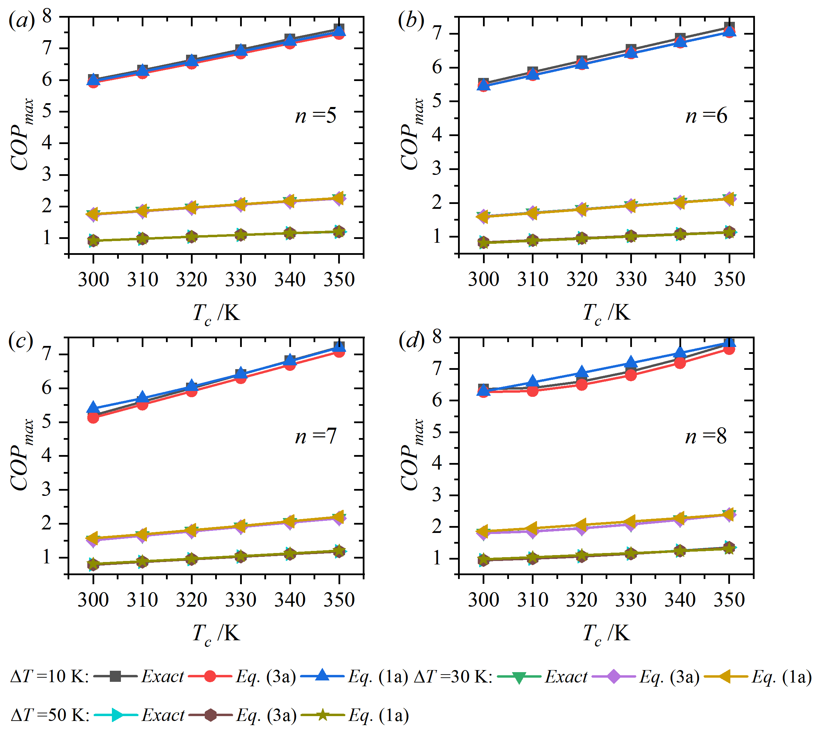
Figure S1. Comparisons of predicted maximum COP by Eqs. (3a) and (1a) to numerical results (n = 5-8).
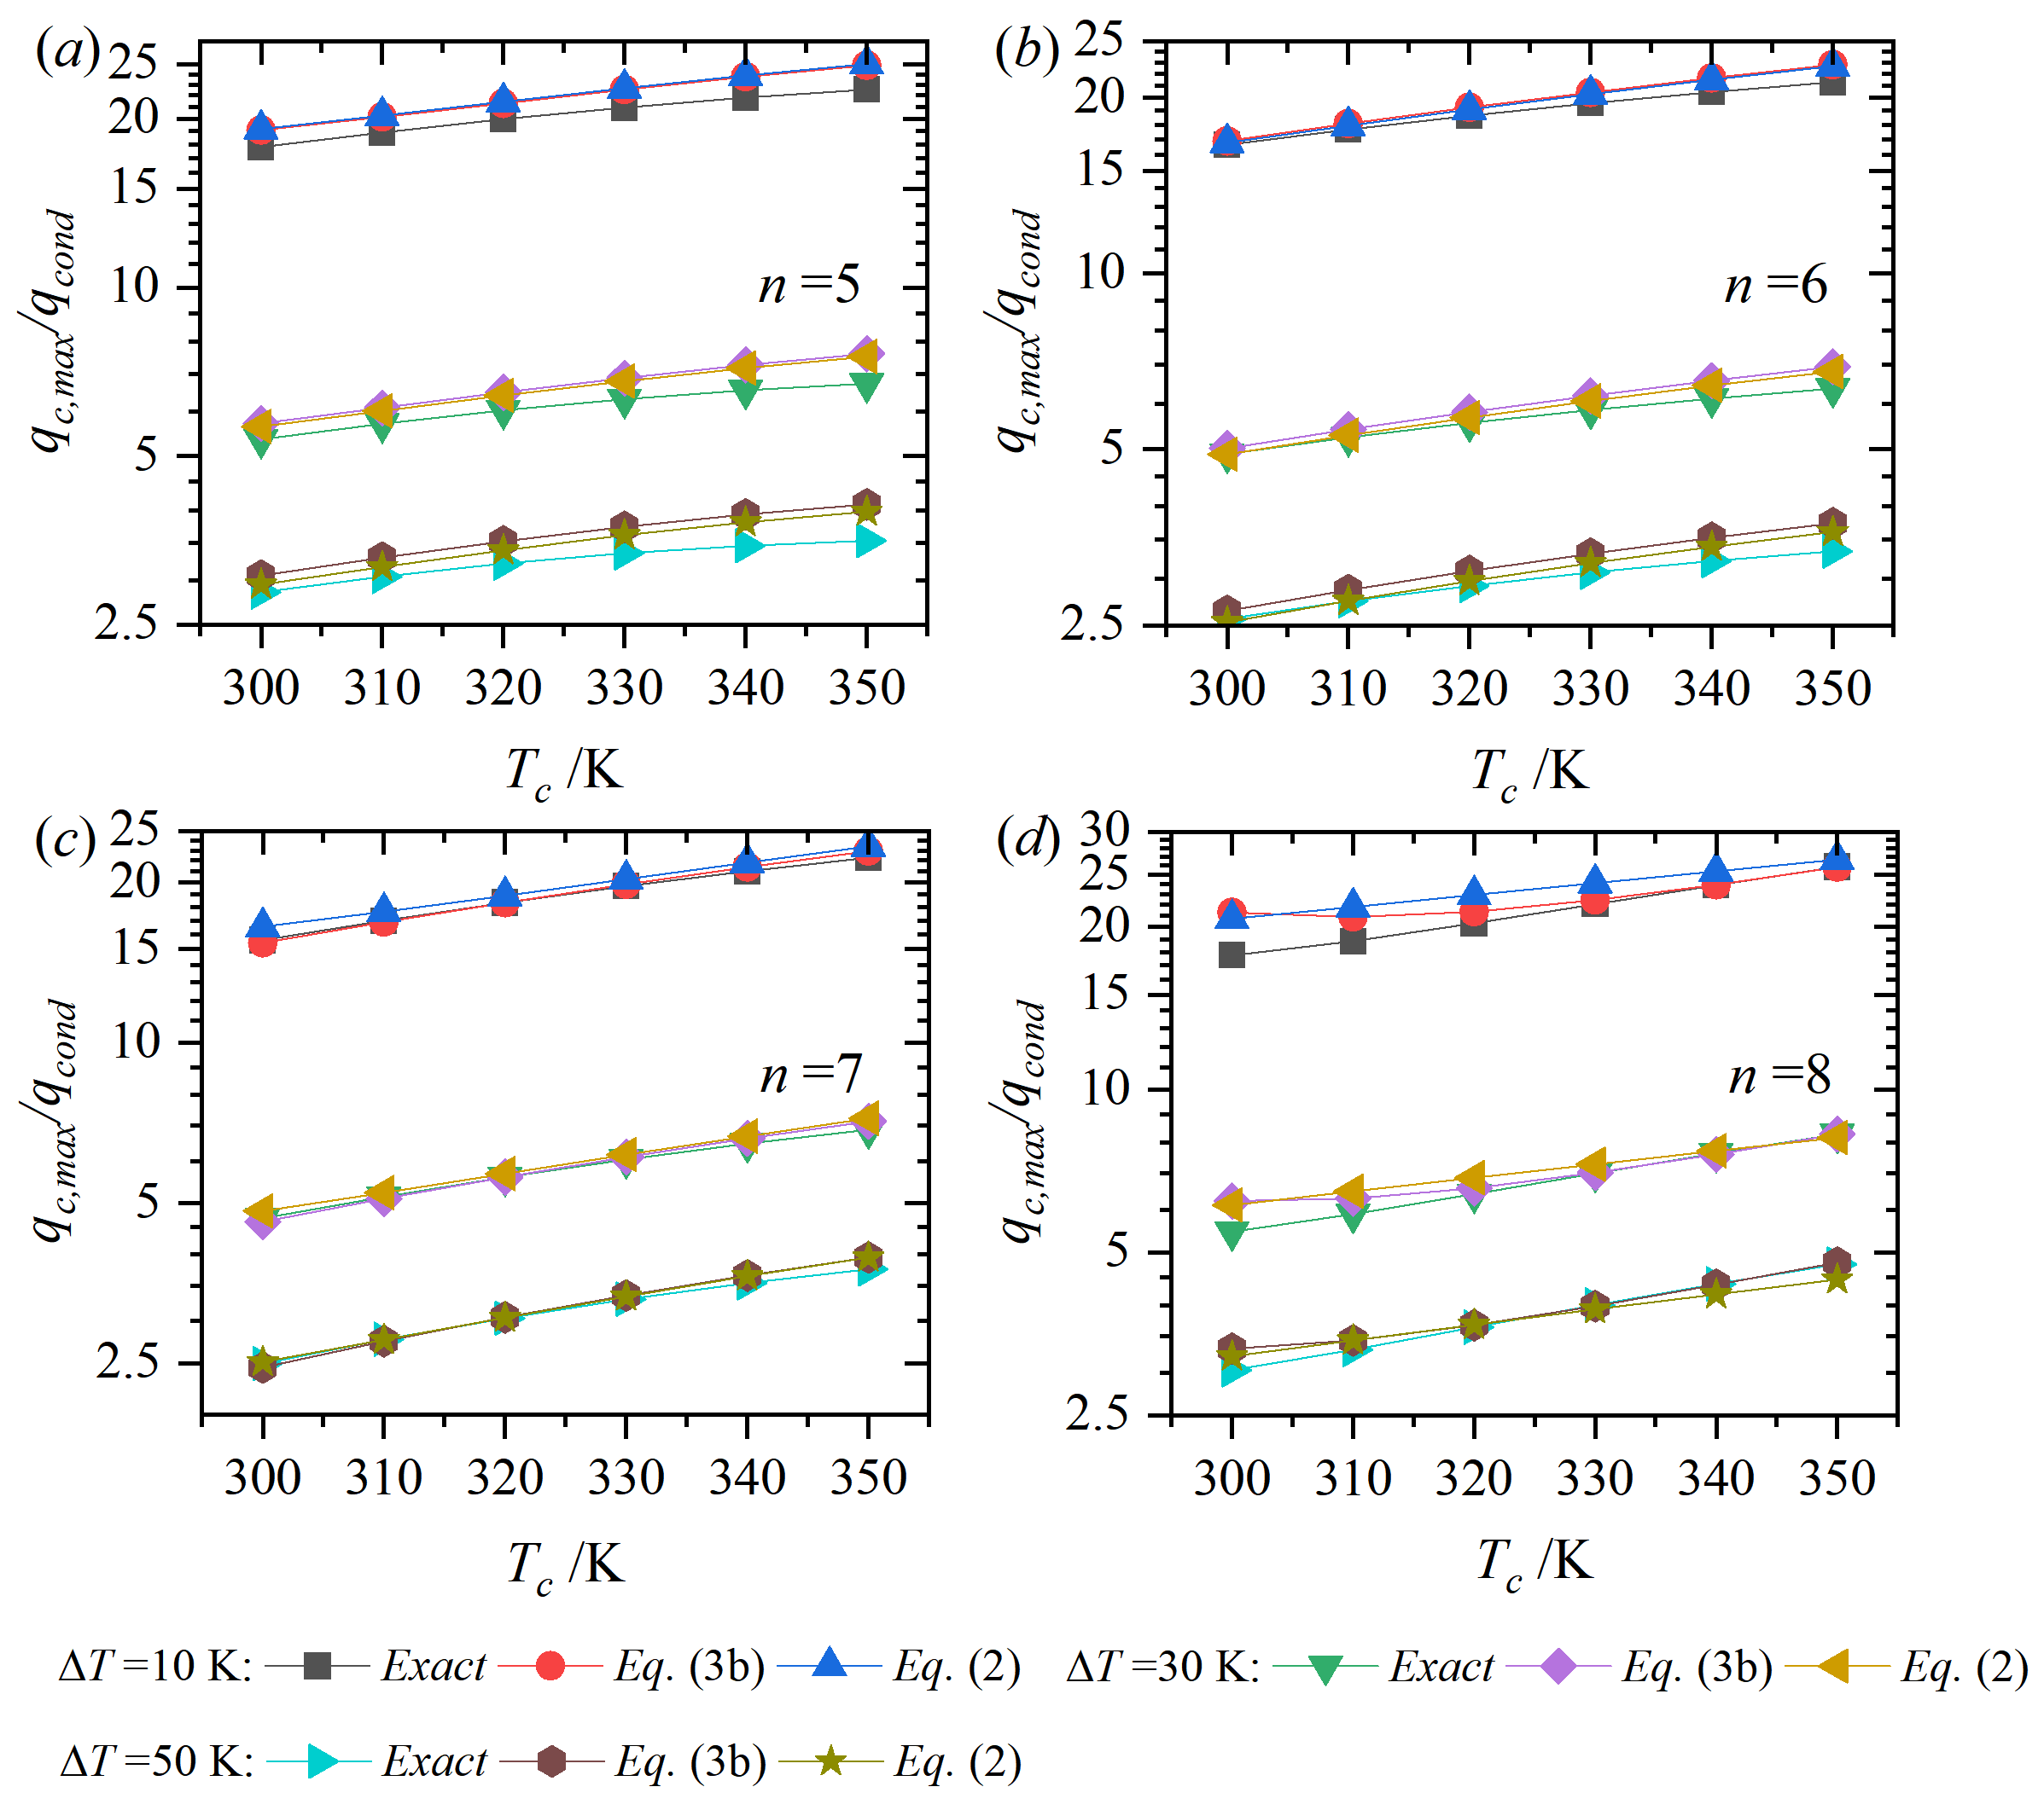
Figure S2. Comparisons of predicted maximum nondimensional cooling power density by Eqs. (3b) and (2) to numerical results (n = 5-8).

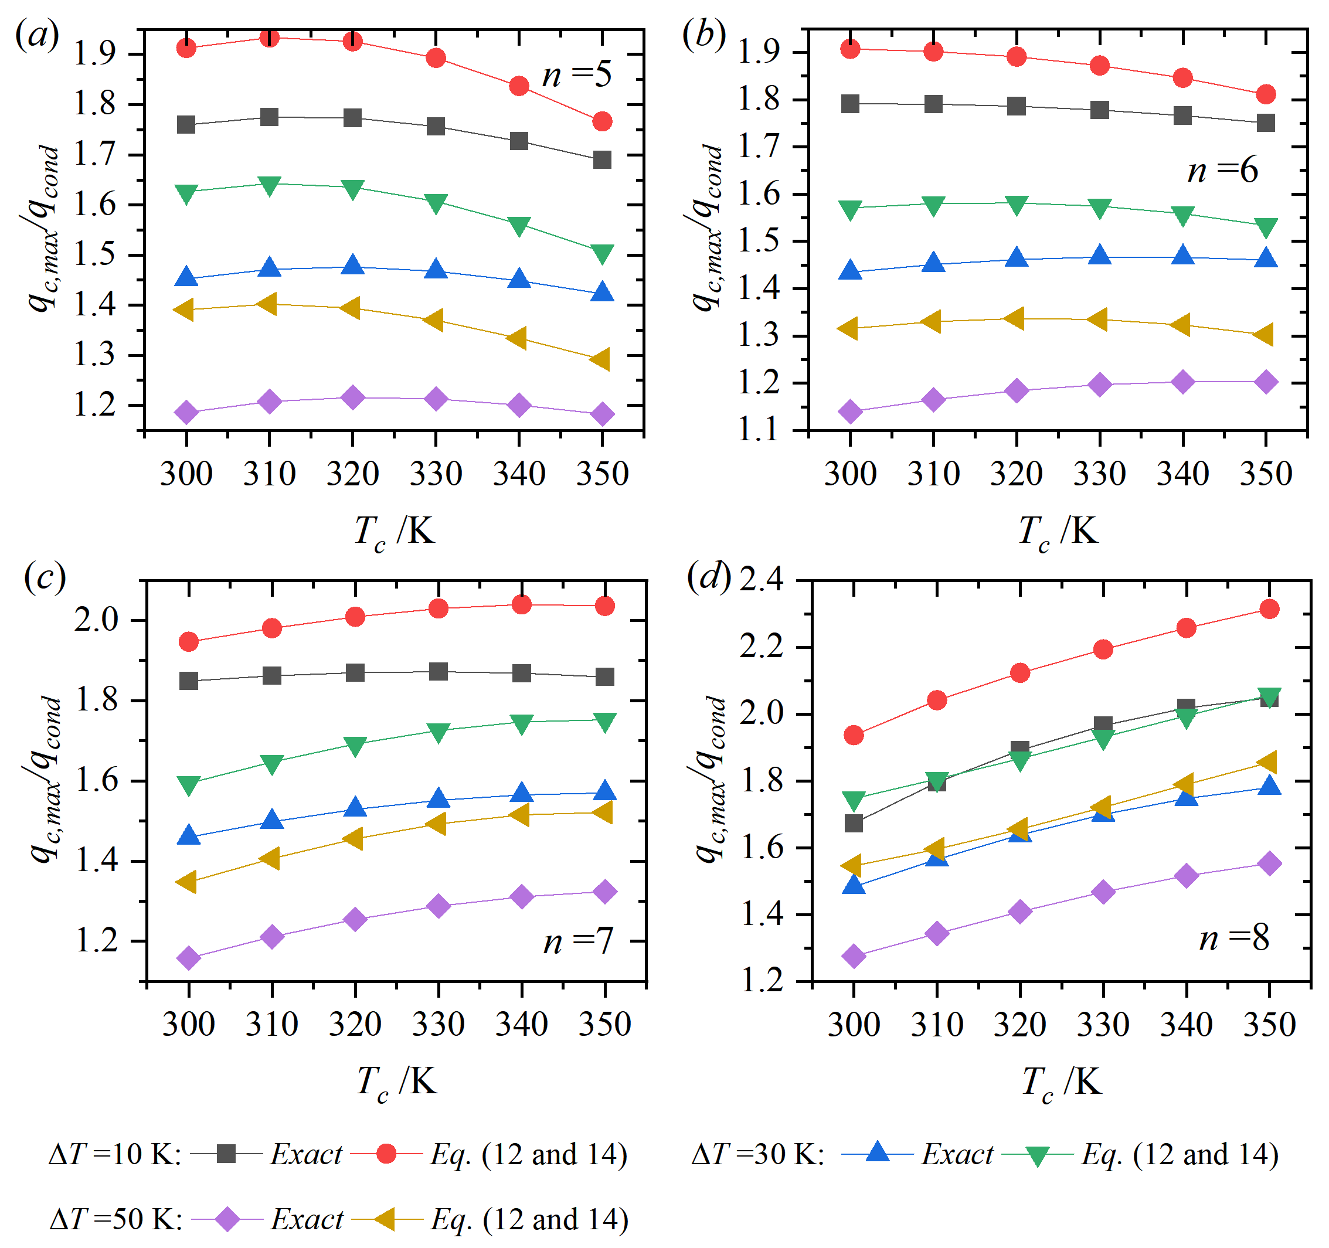
Figure S3. Comparisons of predicted maximum nondimensional cooling power density by Eqs. (12) and (14) to numerical results (n = 5-8).
Figure S4. Comparisons of predicted maximum nondimensional cooling power density by Eqs. (16) and (17) to numerical results (n = 5-8).

Figure S5. Physical properties of the commercial P and N type thermoelectric materials for sub-ambient cooling.

