

**Figure S1.** Chemical structures of the materials used in OLEDs.

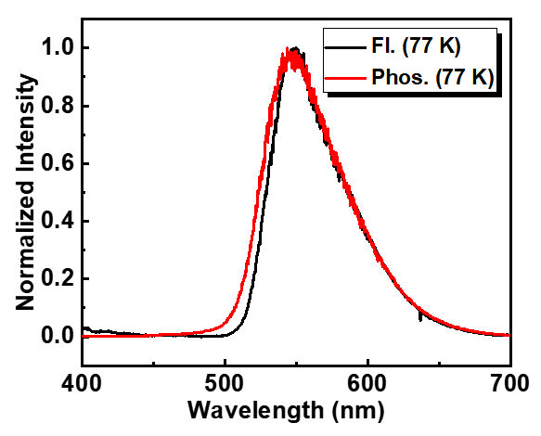

**Figure S2.** Fluorescence spectrum at 77 K (Fl., 77 K) and phosphorescence spectrum at 77 K (Phos., 77 K) of TPXZ-TAZTRZ in toluene solution at 1.0 × 10-5 mol L-1.

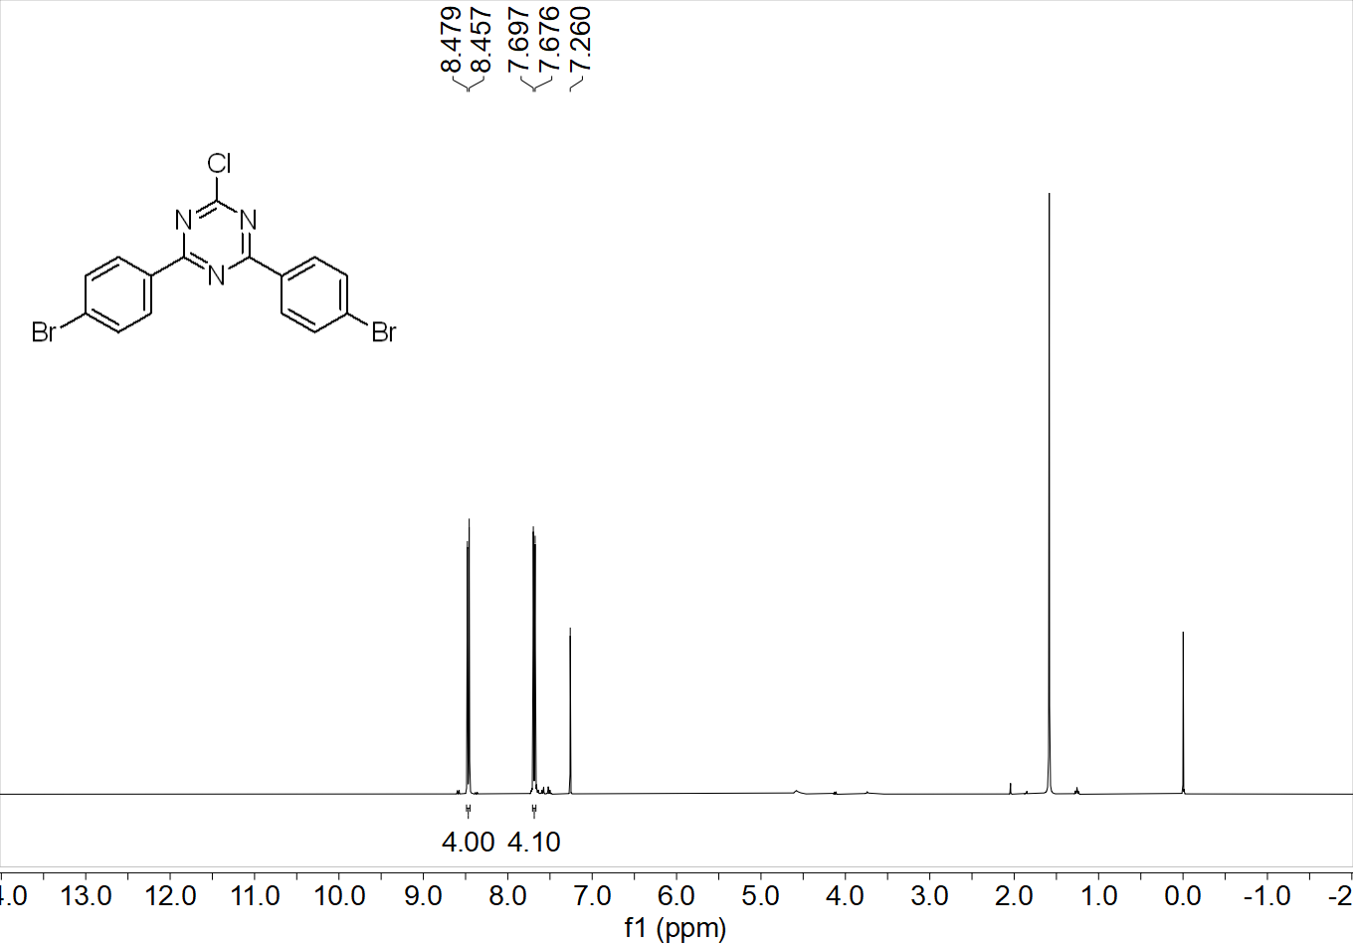

**Figure S3.** 1H NMR spectrum of compound **3** (400 MHz, CDCl3).

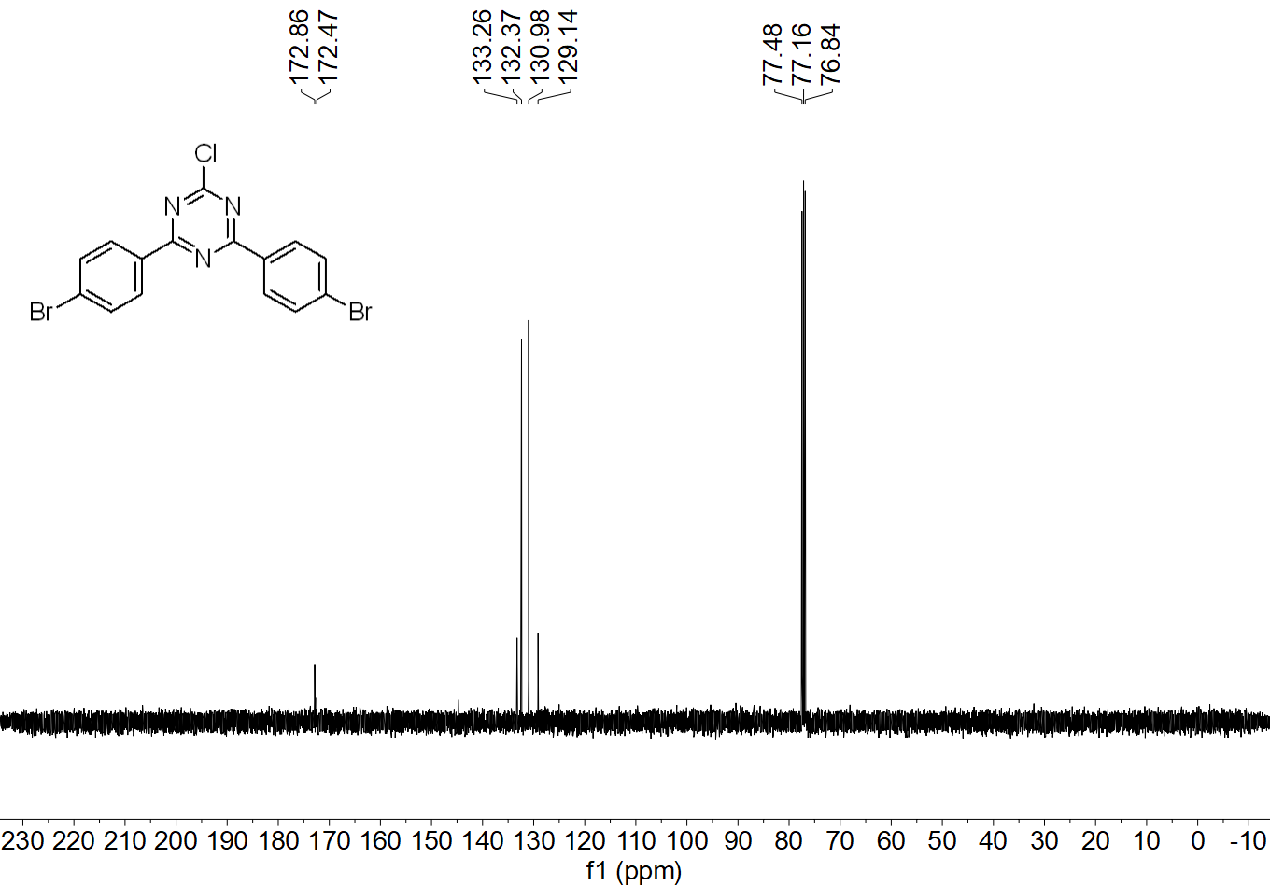

**Figure S4.** 13C NMR spectrum of compound **3** (100 MHz, CDCl3).

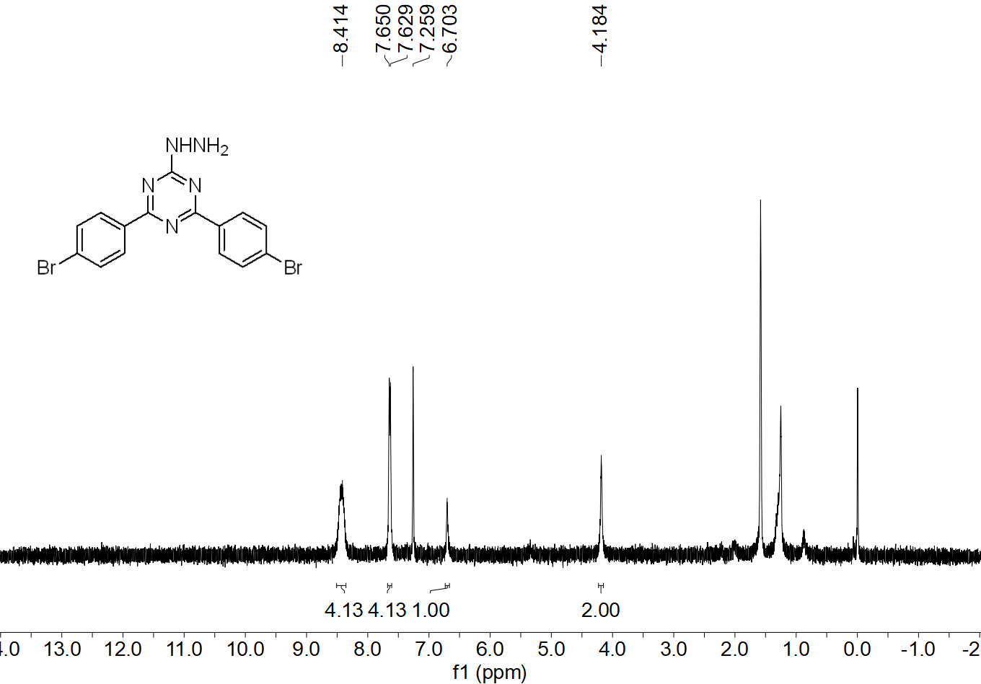

**Figure S5.** 1H NMR spectrum of compound **4** (400 MHz, CDCl3).

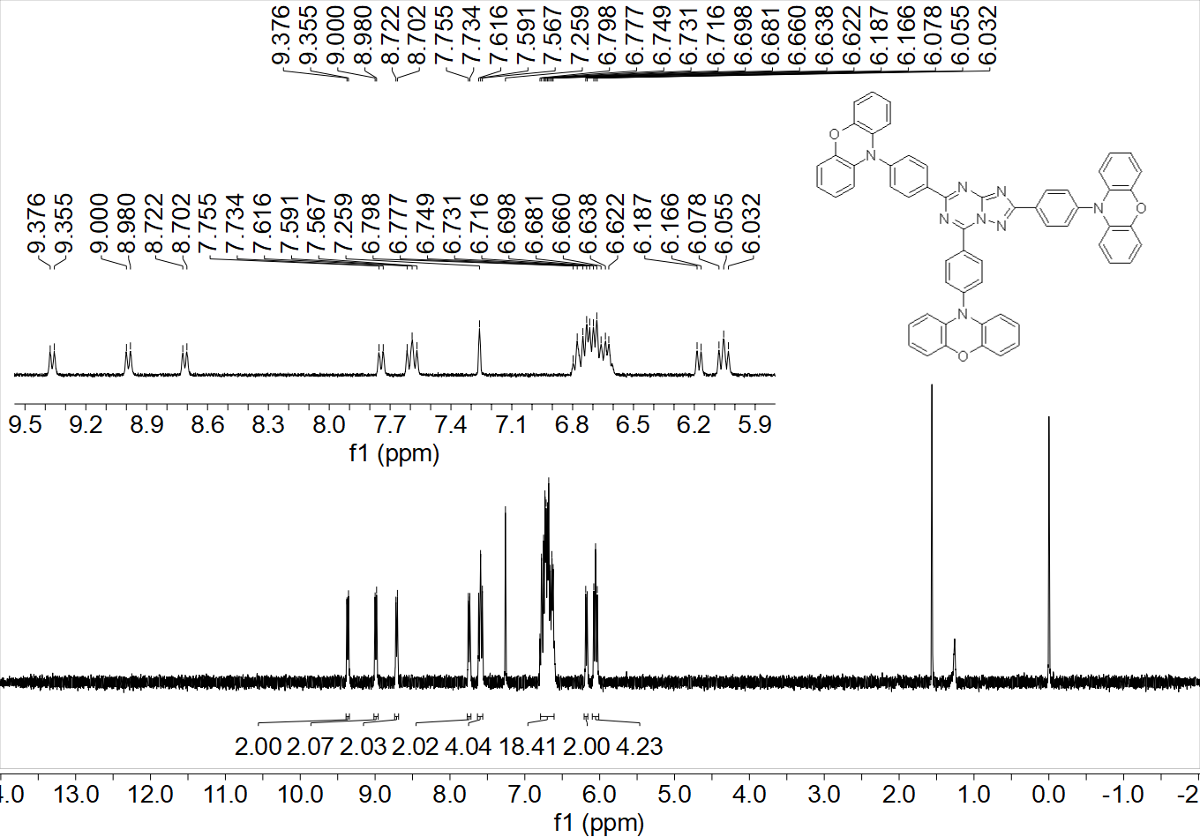

**Figure S6.** 1H NMR spectrum of TAZTRZ-PXZ (400 MHz, CDCl3).

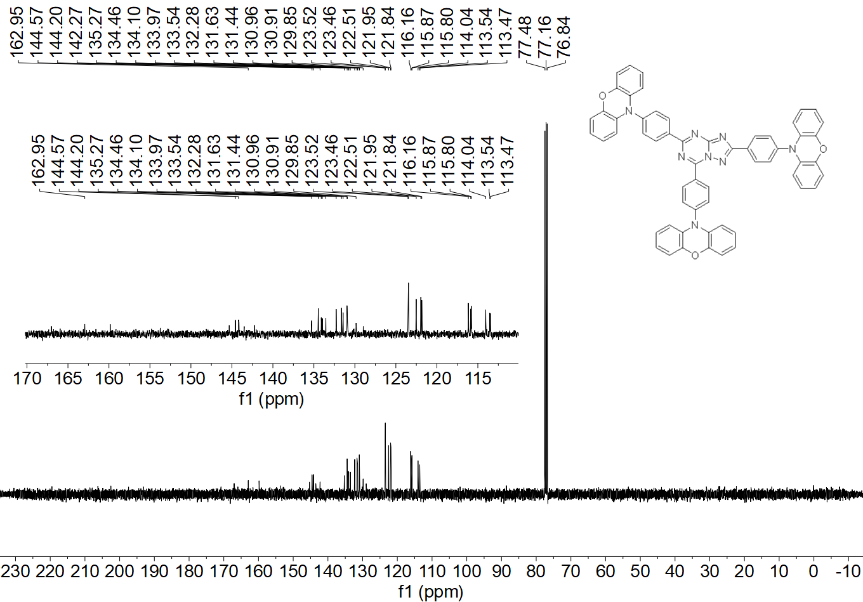

**Figure S7.** 13C NMR spectrum of TAZTRZ-PXZ (400 MHz, CDCl3).