# Synthesis and Characterization

**Synthesis of compound 3**



Firstly, a dried 500 mL Schlenk tube with a magnetic stir bar was charged with compound 1-Bromo-4-iodobenzene (15.56 g, 55.0 mmol). After being evacuated and backfilled with nitrogen (3 times), THF (300.0 mL) was added under N2 atmosphere. After being cooled to 0 ℃, isopropyl magnesium chloride (1.6 M, 60 mmol, 37.5 mL) was vzslowly add to the solution under N2 atmosphere. After the drip, the reaction was allowed to warm to 60 ºC. After being stirred for 2 h, the reaction was cooled to room temperature, (4-bromophenyl) magnesium iodide Grignard reagent **2** was obtained. The next, another dried 500 mL Schlenk tube with a magnetic stir bar was charged with compound **1** (4.61 g, 25 mmol). After being evacuated and backfilled with nitrogen (3 times), THF (150.0 mL) was added under N2 atmosphere. After being cooled to 0 ℃, (4-bromophenyl) magnesium iodide Grignard reagent **2** was slowly add to the solution under N2 atmosphere. After the drip, the reaction mixture was stirred at 60 ºC for 12 h. After the reaction, the mixture was cooled to room temperature. The reaction was quenched with water and extracted with dichloromethane. The combined organic phases were dried over anhydrous Na2SO4, and filtered. Then, the solvent was removed under reduced pressure. Finally, the crude product was purified by neutral silica gel column chromatography (petroleum ether/dichloromethane = 5:1, v/v), and recrystallization in dichloromethane and petroleum ether to obtain white solid **3**, the yield was 53% (5.64 g, 13.25 mmol). 1H NMR (400 MHz, CDCl3): *δ* = 7.69 (d, *J* = 8.4 Hz, 4H), 8.47 (d, *J* = 8.8 Hz, 2H) ppm. 13C NMR (100 MHz, CDCl3): *δ* = 129.14, 130.98, 132.37, 133.26, 172.47, 172.86. ppm. HRMS (ESI+): calcd for C15H979Br79Br35ClN3 [M+H]+ 423.8847, found 423.8895; calcd for C15H981Br79Br35ClN3 [M+H]+ 425.8826, found 425.8887; calcd for C15H979Br79Br37ClN3 [M+H]+ 423.8817, found 423.8786; calcd for C15H981Br79Br37ClN3 [M+H]+ 427.8797, found 425.8687; calcd for C15H981Br81Br35ClN3 [M+H]+ 427.8806, found 427.8780; calcd for C15H981Br81Br37ClN3 [M+H]+ 429.8776, found 429.8657.

**Synthesis of compound 4**



A dried 300 mL round bottom flask with a magnetic stir bar was charged with compound **3** (11.06 g, 26.0 mmol) and 180.0 mL hydrazine hydrate. After being stirred at 60 ºC for 6 h, the reaction mixture was cooled to room temperature. The resulted solution was poured into ice water (500.0 mL), the white solid was filtered under reduced pressure, the precipitated white solid is filtered under reduced pressure, and washed with a lot of water until the pH is approximately 7. The white solid was dried under vacuum, then purified by neutral silica gel column chromatography (petroleum ether/dichloromethane = 5:1, v/v), and recrystallized in dichloromethane and petroleum ether to obtain white solid **4** with a yield of 95% (10.40 g, 24.7 mmol). 1H NMR (400 MHz, CDCl3): *δ* = 4.18 (s,2H), 6.70 (s,1H), 7.64 (d, *J* = 8.4 Hz, 4H), 8.41 (s,4H) ppm. HRMS (ESI+): calcd for C15H1179Br79BrKN5 [M+K]+ 457.9613, found 457.9638; calcd for C15H1179Br81BrKN5 [M+K]+ 459.8993, found 459.8984; calcd for C15H1181Br81BrKN5 [M+K]+ 461.8972, found 461.8996.

**Synthesis of crude compound 5**



A dried 300 mL round bottom flask with a magnetic stir bar was charged with compound **4** and 4-Bromobenzaldehyde (4.63 g, 25.0 mmol). After being evacuated and backfilled with nitrogen (3 times), EtOH (300.0 mL) was added under N2 atmosphere. After being stirred at 90 ºC for 6 h, the reaction mixture was cooled to room temperature. The resulted solution was poured into ice water (500.0 mL). The white solid was filtered under reduced pressure and dried under vacuum to obtain crude product **5**. Due to the extremely poor solubility of **5**, the structure of the compound cannot be determined by NMR, and the formation of product **5** is roughly determined by Thin-Layer Chromatography analysis (TLC).

**Synthesis of crude compound 6**



A dried 300 mL round bottom flask with a magnetic stir bar was charged with compound **5** and DCM (50.0 mL), then PhI(AcO)2 (8.05 g, 25.0 mmol) was added at room temperature. After being stirred at room temperature for 6 h, the reaction system was removed by vacuum distillation to obtain a light-yellow crude product **6**. Due to the extremely poor solubility of **6**, the structure of the compound cannot be determined by NMR, and the formation of product **6** is roughly determined by TLC.

**Synthesis of crude compound 7**



A dried 200 mL Schlenk tube with a magnetic stir bar was charged with compound **6** and K2CO3 (13.80 g, 100.0 mmol). After being evacuated and backfilled with nitrogen (3 times), *o-*DCB (300.0 mL) was added under N2 atmosphere. After being stirred at 190 ºC for 48 h, the reaction mixture was cooled to room temperature. The solvent is removed by vacuum distillation. The resulted solution was poured into a large amount of water, and washed with a lot of water until the pH is approximately 7 to obtain a yellow crude product **7**. Due to the extremely poor solubility of **7**, the structure of the compound cannot be determined by NMR, and the formation of product **7** is roughly determined by TLC.

**Synthesis of TAZTRZ-PXZ**



A dried 200 mL Schlenk tube with a magnetic stir bar was charged with coarse product **7** (4 g), phenoxazine (3.30 g，18.0 mmol), Pd(OAc)2 (0.07 g，0.3 mmol)，*t*Bu3PHBF4 (0.17 g，0.6 mmol) and K2CO3 (3.31 g，24.0 mmol). After being evacuated and backfilled with N2 (3 times), toluene (50.0 mL) was added under N2 atmosphere. After being stirred at 120 ºC for 12 h, the reaction mixture was cooled to room temperature. The reaction was quenched with water and extracted with dichloromethane. The combined organic phases were dried over anhydrous Na2SO4, and filtered. Then, the solvent was removed under reduced pressure. Finally, the crude product was purified by neutral silica gel column chromatography (petroleum ether/dichloromethane = 3:1, v/v), and recrystallized in *n*-hexane and dichloromethane to obtain a red solid with a yield of 21%. 1H NMR (400 MHz, CDCl3): *δ* = 6.05 (t, *J* = 9.2 Hz, H), 6.18 (d, *J* = 8.4 Hz, 2H), 6.62-6.80 (m, 18H), 7.59 (t, *J* = 9.6 Hz, 4H), 7.74 (d, *J* = 8.4 Hz, 2H), 8.71 (d, *J* = 8.0 Hz, 2H), 8.99 (d, *J* = 8.0 Hz, 2H), 9.36 (d, *J* = 8.4 Hz, 2H) ppm. 13C NMR (100 MHz, CDCl3): *δ* = 113.47, 113.54, 114.04, 115.80, 115.87, 116.16, 121.84, 121.95, 122.51, 123.46, 123.52, 129.85, 130.91, 130.96, 131.44, 131.63, 132.28, 133.54, 133.97, 134.10, 134.46, 135.27, 142.27, 144.20, 144.57, 162.95 ppm. HRMS (ESI+): calcd for C58H37N8O3 [M+H]+ 893.2984, found 893.2981.

# Method of Theoretical Calculations

All theoretical calculations were performed using Gaussian 09 serials software. All theoretical calculations were calculated under B3LYP/def2svp level. The FMOs distributions were calculated on the basis of crystal structures and visualized using Gaussview 5.0 software. The radiative decay rate (*k*R) and reverse intersystem crossing rate (*k*RISC) could be estimated using the following equations[1-3]:

*Φ*P = C1*Φ*PL

*Φ*d = C2*Φ*PL

*k*R = *Φ*P/*τ*p = *Φ*PLC1/*τ*p

*k*ISC = (1-*Φ*P)/*τ*p = (1-*Φ*PLC1)/*τ*p

*k*RISC = *Φ*d/(*k*ISC*τ*p*τ*d*Φ*p) = C2/[C1*τ*d(1-*Φ*PLC1)]

*k*FET = 1/*τ*p(3)- 1/*τ*p(2)

*k*DET = 1/*τ*d(3)- 1/*τ*d(2)+ *k*ISC×*k*RISC×[*τ*p(3) -*τ*p(2)]

Where *Φ*p and *Φ*d represent prompt and delayed fluorescence components and can be distinguished from the total *Φ*PL by comparing the integrated intensities of prompt (C1) and delayed components (C2) in the transient PL spectra. *τ*p(3) and *τ*d(3) represent prompt and delayed fluorescence lifetime for ternary film, respectively. *τ*p(3) and *τ*d(3) represent prompt and delayed fluorescence lifetime for binary film, respectively.

The Förster radium (*R*0) was estimated as follows according to the references[4,5].

Where *Φ*PL is the photoluminescence quantum efficiency of the sensitizer in the absence of guest, *k*2 is orientation factor commonly assumed to be 2/3 for a random distribution of donor–acceptor pairs, *NA* is the Avogadro’s number, *n* is the refractive index usually assumed to be 1.7 for most of the organic materials, $\int_{0}^{∞}{F_{S}(λ)ε_{E}(λ)λ^{4}dλ}$ is the spectral overlap integral between sensitizer photoluminescence (*F*S(*λ*)) and the emitter absorption (*ε*E*λ*)in which *F*S(*λ*) is thesensitizer’s fluorescence normalized by area, and *λ* is the wavelength.

**References**

1.Aizawa N, Shikita S, Yasuda T.Spin-dependent exciton funneling to a dendritic fluorophore mediated by a thermally activated delayed fluorescence material as an exciton-harvesting host. Chem. Mater. 2017;29(16):7014-7022. [DOI:10.1021/acs.chemmater.7b02606]

2.Masui K, Nakanotani H, Adachi C.Analysis of exciton annihilation in high-efficiency sky-blue organic light-emitting diodes with thermally activated delayed fluorescence. Org Electron. 2013;14(11):2721-2726. [DOI:10.1016/j.orgel.2013.07.010]

3.Song XZ, Zhang DD, Zhang YW, Lu Y, Duan L.Strategically Modulating carriers and excitons for efficient and stable ultrapure‐green fluorescent OLEDs with a sterically hindered BODIPY dopant. Adv Opt Mater. 2020;8(15):2000483. [DOI:10.1002/adom.202000483]

4.Kawamura Y, Brooks J, Brown JJ, Sasabe H, Adachi C.Intermolecular interaction and a concentration-quenching mechanism of phosphorescent Ir(III) complexes in a solid film. Phys Rev Lett. 2006;96(1):017404. [DOI:10.1103/PhysRevLett.96.017404]

5.Jing YY, Li NQ, Cao XS, Wu H, Miao JS, Chen ZX, et al. Precise modulation of multiple resonance emitters toward efficient electroluminescence with pure-red gamut for high-definition display. Sci Adv. 2023;9(30):eadh8296. [DOI:10.1126/sciadv.adh8296]

**Additional Data and Spectra**



**Figure S1.** Chemical structures of the materials used in OLEDs.

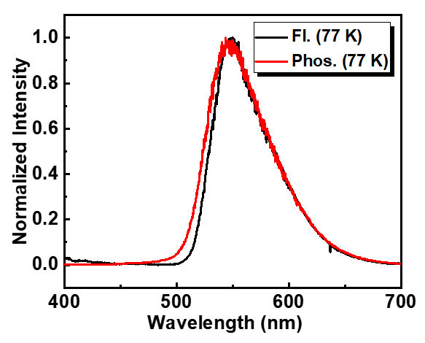

**Figure S2.** Fluorescence spectrum at 77 K (Fl., 77 K) and phosphorescence spectrum at 77 K (Phos., 77 K) of TPXZ-TAZTRZ in toluene solution at 1.0 × 10-5 mol L-1.

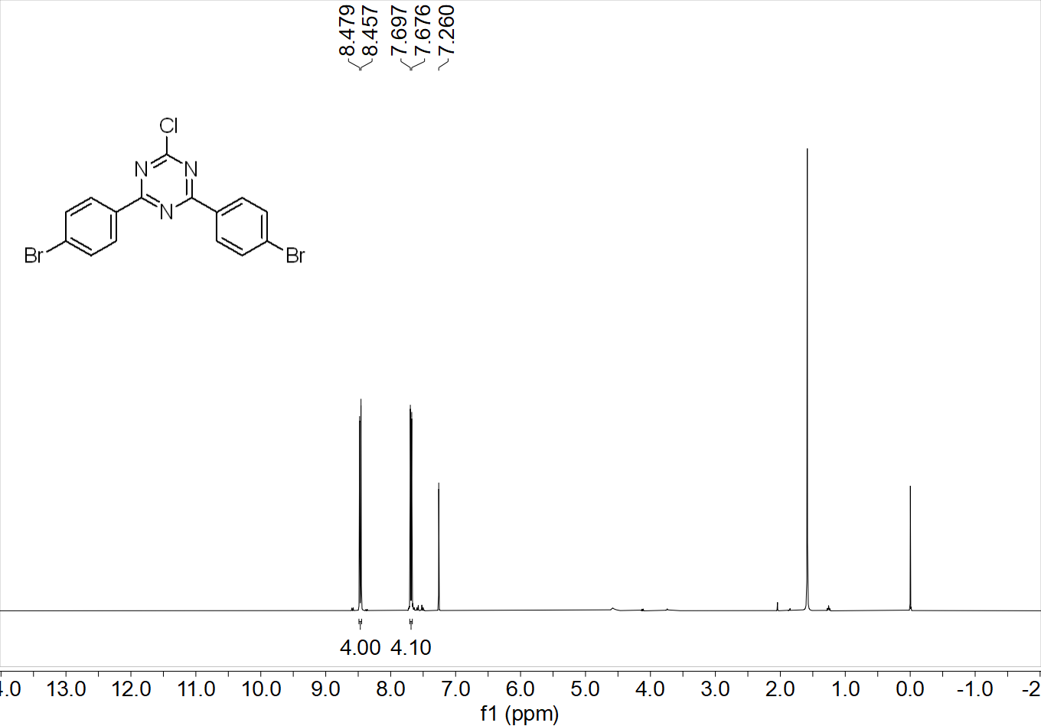

**Figure S3.** 1H NMR spectrum of compound **3** (400 MHz, CDCl3).

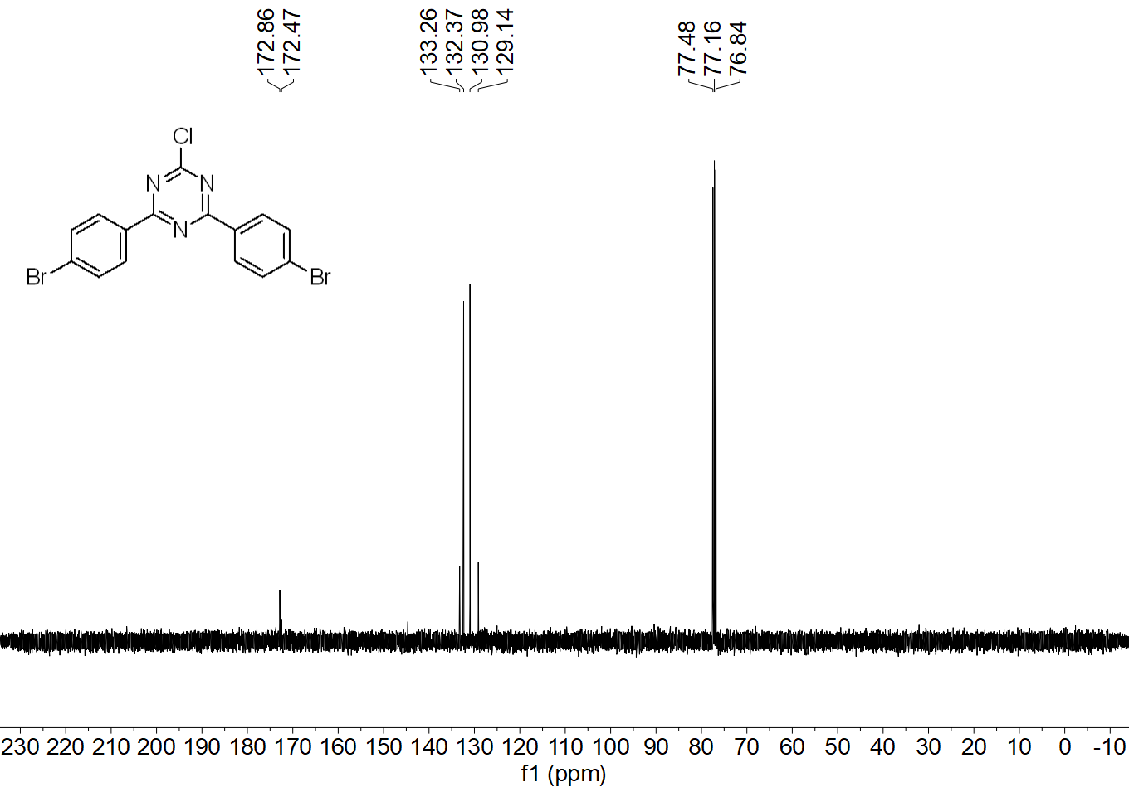

**Figure S4.** 13C NMR spectrum of compound **3** (100 MHz, CDCl3).

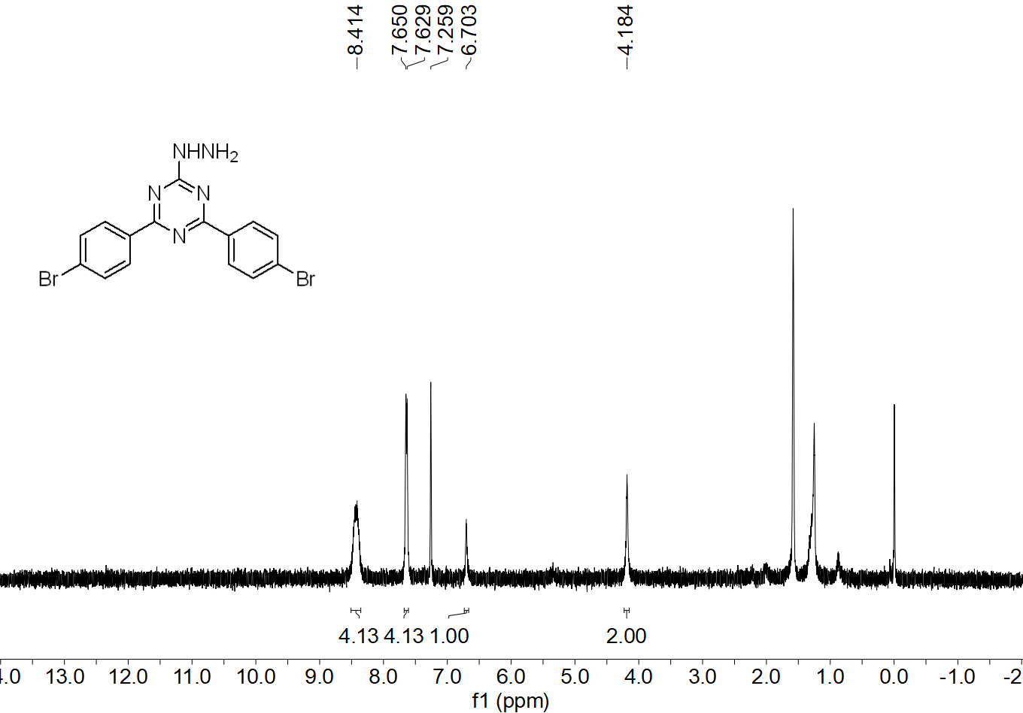

**Figure S5.** 1H NMR spectrum of compound **4** (400 MHz, CDCl3).

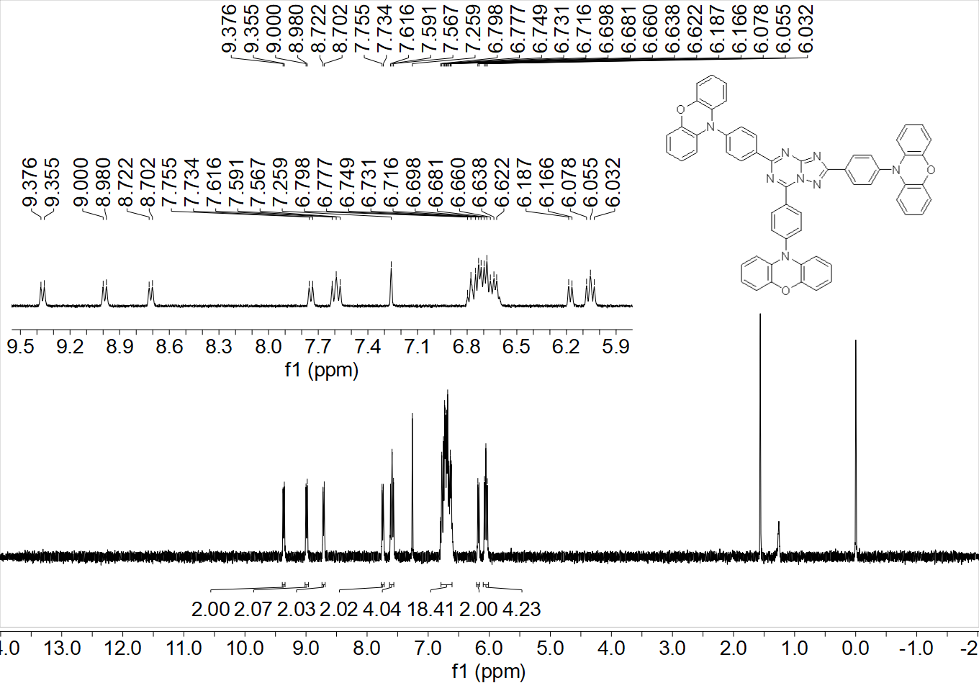

**Figure S6.** 1H NMR spectrum of TAZTRZ-PXZ (400 MHz, CDCl3).

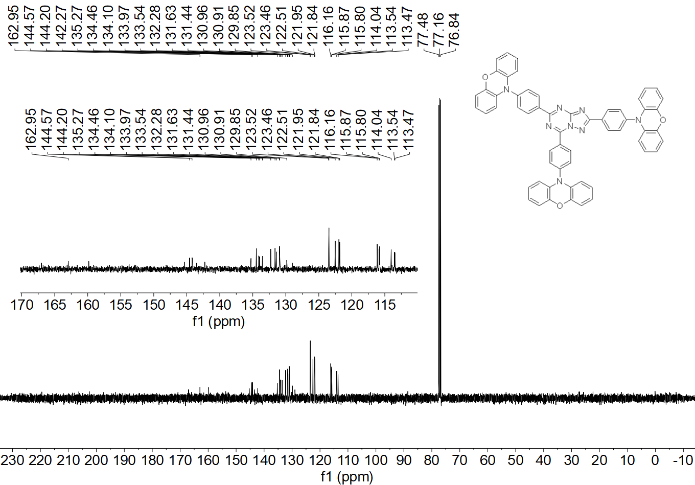

**Figure S7.** 13C NMR spectrum of TAZTRZ-PXZ (400 MHz, CDCl3).

**Table S1**. Transient PL characteristic and rate constants of the emitting system that contains DBP emitter, TAZTRZ-PXZ sensitizer and CBP host at a concentration ratio of *x*: 10: 100 (298 K).

|  |  |  |  |  |  |  |  |  |
| --- | --- | --- | --- | --- | --- | --- | --- | --- |
| Film | *x* | *Φ*PL  [%] | *τ*p  [ns] | *τ*d  [μs] | *k*RISC  [105 s-1] | *k*ISC  [107 s-1] | *k*FET  [108 s-1] | *k*DET  [106 s-1] |
| Binary  Ternary | 0  2 | 55  - | 23.4  4.9 | 0.84  0.26 | 10.0  - | 2.75  - | -  1.61 | -  2.66 |

**Table S2**. Detailed calculation data for *R*0.

|  |  |  |  |  |  |
| --- | --- | --- | --- | --- | --- |
| [nm6 mol-1] | *J*(λ)  [M-1 cm-1 nm4] |  | *n* | *Φ*PL  [%] | *R*0  [nm] |
| 5.71×1034 | 5.71×1013 | 0.67 | 1.7 | 0.68 | 8.0 |