# 1. Scoring of strategic factors

The scoring table is collated and fully synthesized to obtain the final strategic factor scores. **Table S1** shows scoring of strategic factors.

**Table S1.** Scoring of strategic factors.

|  |  |  |  |
| --- | --- | --- | --- |
| Target level | Standardized layer  (Dimension) | Indicator level (Factors) | Score |
| Use of DT | Strength (S) | S1:The capacity of analyzing large amounts of data. | 4.35 |
| S2:The capacity of monitoring the status of a system in real time. | 4.60 |
| S3:Accurate prediction and decision support. | 4.75 |
| S4:Improve efficiency by optimizing resource allocation and processes. | 4.55 |
| Weakness  (W) | W1:Complexity requirements and high costs for implementation. | -4.80 |
| W2:High dependence on high quality and large scale data. | -4.35 |
| W3:High demand for specialized knowledge and skills. | -4.85 |
| W4:Lack of standardization and a risk that sensitive information may be compromised . | -4.40 |
| Opportunity  (O) | O1:Growing market demand for DT. | 3.20 |
| O2:Support and promotion by government and industry policies. | 2.90 |
| O3:Rapid technological advancement and its related fields. | 3.75 |
| O4:Establishment of standards and regulations. | 4.60 |
| Threat (T) | T1:Competitive technological pressures inside and outside the DT field. | -4.90 |
| T2:Complex integration with other intelligent building management technologies. | -3.80 |
| T3:Insufficient number of hardware devices for DT systems and potentially high maintenance costs. | -4.70 |
| T4:Uncertainty in the use created by rapid changes in the market environment and customer needs. | -4.00 |

# 2. Construct judgement matrices and testing consistency

Based on the strengths and weaknesses of DT, and also around the current opportunities and threats, a two-by-two comparison is scored, resulting in a judgement matrix A as follows. The judgement matrix (A) is

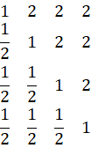

The strength matrix (S) is

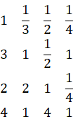

The weakness matrix (W) is

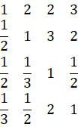

The opportunity matrix (O) is

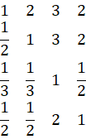

The challenge matrix (T) is

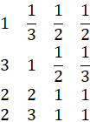

# 3. Calculate the weights of the factors and test their consistency

Calculate the AHP evaluation index naturalized one eigenvector λ: calculate the sum of the rows of the judgement matrix, then calculate the average of the rows, and finally divide the average of the rows by the sum of the averages of the 4 rows. This part of the calculation was done through EXCEL software. The result is

λA=

|  |
| --- |
| 1.4130 |
| 1.0312 |
| 1.0312 |
| 0.5247 |

λS=

|  |
| --- |
| 0.3603 |
| 1.0141 |
| 0.9282 |
| 1.6974 |

λW=

|  |
| --- |
| 1.6618 |
| 1.1578 |
| 0.5032 |
| 0.6771 |

λO=

|  |
| --- |
| 1.6473 |
| 1.1721 |
| 0.4318 |
| 0.7488 |

λT=

|  |
| --- |
| 0.5208 |
| 0.8172 |
| 1.2521 |
| 1.4100 |

The maximum eigenvalue is obtained by MATLAB. The calculation process is as follows in **Table S2**.

The maximum eigenvalue of the A matrix is 4.1213. The maximum eigenvalue of the S matrix is 4.2106. The maximum eigenvalue of the W matrix is 4.1649. The maximum eigenvalue of the O matrix is 4.0710. The maximum eigenvalue of the T matrix is 4.2353.

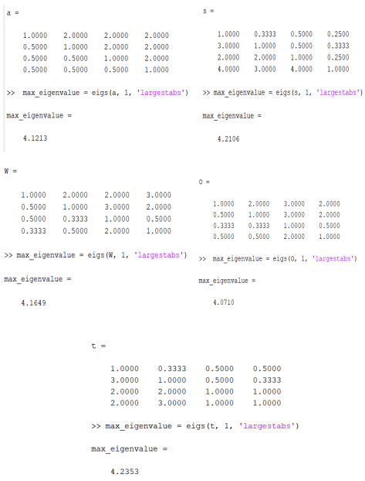

**Table S2.** Maximum eigenvalue calculated by MATLAB